Procedural Languages
C, Pascal, FORTRAN, and similar languages are procedural languages. . A program in a procedural language is a list of instructions, such as get some input, add these numbers, divide by some number, display that output etc.

Division into Functions
In case when we have more than one related instructions, we define functions. Thus procedural program is divided into functions which have some clearly defined goal in the program.

The idea of breaking a program into functions can be further extended by grouping a number of functions together into a larger entity called a module (which is often called a “File”).
Dividing a program into functions and modules is one of the cornerstones of structured programming.

Problems with Structured Programming
No matter how well the structured programming approach is implemented, large programs become excessively complex.
What are the reasons for these problems with procedural languages?
There are two related Problems.
- First, functions have unrestricted access to global data.
- Second, unrelated functions and data, the basis of the procedural approach, provide a poor model of the real world.

Let’s take an example of an inventory program. One important global data item in such a program is the collection of items in the inventory. Various functions access this data to input a new item, display an item, modify an item, and so on.

Unrestricted Access
In a procedural program, for example C, there are two kinds of data.
Local data is hidden inside a function, and is used exclusively by the function. In the Inventory program a display function might use local data to remember which item it was displaying. Local data is closely related to its function and is safe from modification by other functions.
However, when two or more functions would like to access the most important data in a program—then the data must be made global, as our collection of inventory items is. Global data can be accessed by any function in the program.

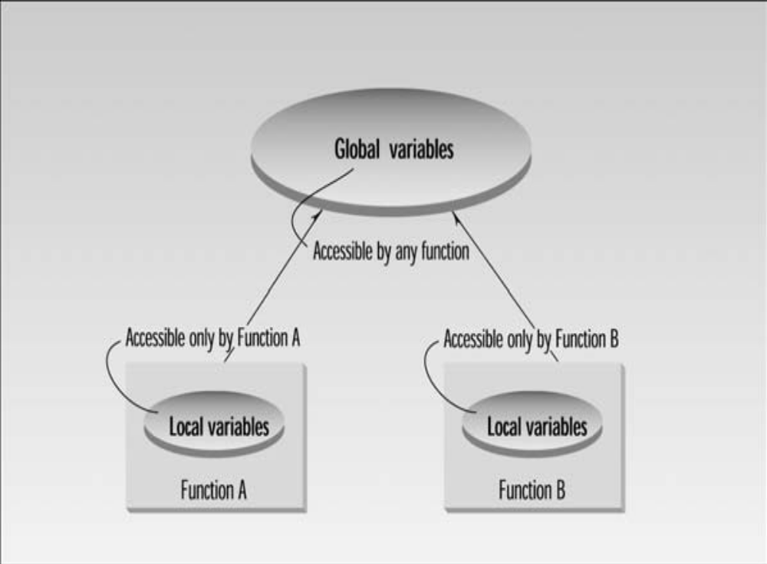

Global and local variables.

In a large program, there are many functions and many global data items. The problem with the procedural approach is that this leads to an even larger number of potential connections between functions and data, as shown below:

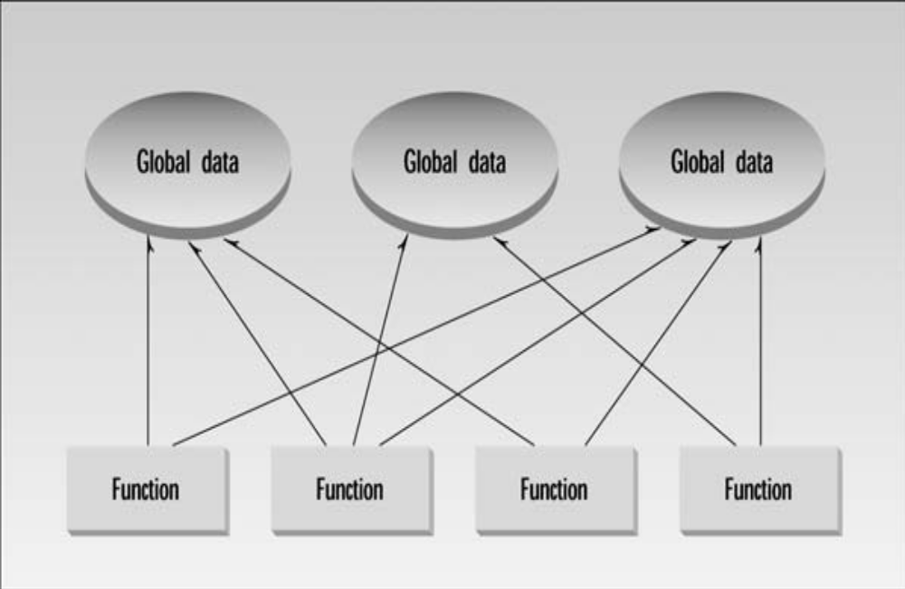

The procedural approach.

This large number of connections causes problems in several ways. First, it makes a program’s structure difficult to understand. Second, it makes the program difficult to modify. A change made in a global data item may necessitate rewriting all the functions that access that item.
For example, in our inventory program, someone may decide that the product codes for the
Inventory items should be changed from 5 digits to 12 digits. This may necessitate a change from a short to a long data type.
Now all the functions that operate on the data must be modified to deal with a long instead of a short.
When data items are modified in a large program it may not be easy to tell which functions access the data, and even when you figure this out, modifications to the functions may cause them to work incorrectly with other global data items.

Real-World Modelling
The second—and more important—problem with the procedural approach is that its arrangement of separate data and functions does a poor job of modelling things in the real world. In the physical world we deal with objects such as people, company, cars etc. Such objects aren’t like data and they aren’t like functions. Complex real-world objects have both attributes and behaviour.

Attributes
Examples of attributes (sometimes called characteristics) are, for people name ,address,age; and, for cars, horsepower and number of doors etc. As it turns out, attributes in the real world are equivalent to data in a program: they have a certain specific values,
such as mumbai (for address) or four (for the number of doors).

Behaviour
Behaviour is something a real-world object does for some purpose. If you ask for a withdraw, ATM machine will give u cash. If you apply the brakes in a car, it will generally stop. Withdraw cash and stopping are examples of behaviour.
Behaviour is like a function: you call a function to do something (display the inventory, for example) and it does it.

The Object-Oriented Approach
Object-oriented programming was developed because limitations were discovered in procedural programming.

The fundamental idea behind object-oriented languages is to combine into a single unit both data and the functions that operate on that data. Such a unit is called an object.

An object’s functions, called member functions, typically provide the only way to access its data. If you want to read a data item in an object, you call a member function in the object. It will access the data and return the value to you. You can’t access the data directly.
The data is hidden (private), so it is safe from accidental alteration. Data and its functions are said to be encapsulated into a single entity. Data encapsulation and data hiding are key terms in the description of object-oriented languages.
If you want to modify the data in an object, you know exactly what functions interact with it: the member functions in the object. No other functions can access the data. This simplifies writing, debugging, and maintaining the program.

An object oriented application typically consists of a number of objects, which communicate with each other by calling each other’s member functions.

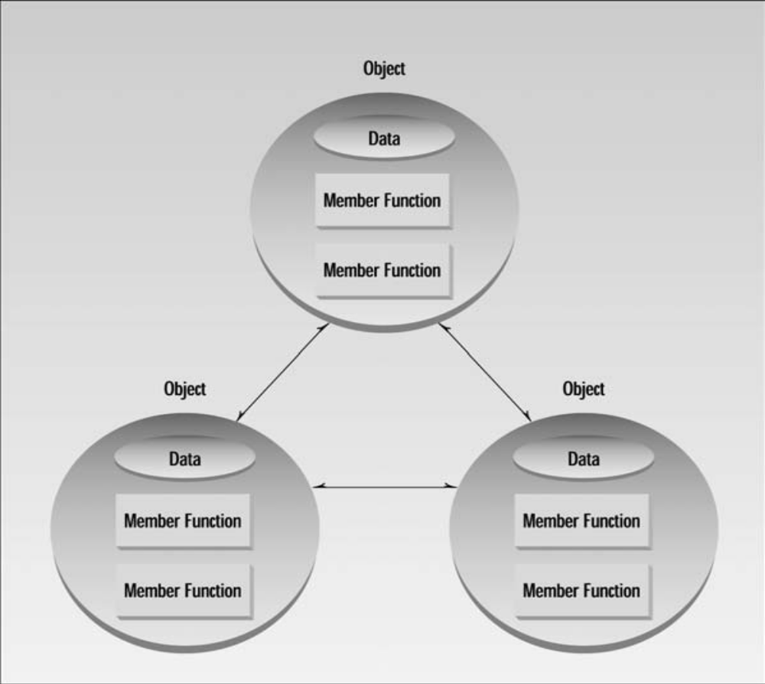

Objects Communicate with each other

Calling an object’s member function is also referred to as sending a message to the object.

e.g. Person object invokes “withdrawCash()” member function of ATM object.

Real World Example:

Let’s take an example of objects as departments—such as sales, accounting, personnel, and so on—in a company.

Each department has its own its own data: the accounting department has payroll figures, the sales department has sales figures, and the personnel department keeps records of each employee, and so on.

The people in each department control and operate on that department’s data. Dividing the
Company into departments makes it easier to comprehend (understand) and control the company’s activities, it also helps maintain the integrity of the information used by the company. The accounting department, for instance, is responsible for the payroll data. If you’re a sales manager, and you need to know the total of all the salaries paid in the southern region in July, you don’t just walk into the accounting department and start rummaging through file cabinets. Rather you send a memo (Sales manager will invoke member function of Accounting Department) to the appropriate person in the Accounts department, then wait for that person to access the data and send you a reply with the information you want. This ensures that the data is accessed accurately and that it is not corrupted by inept outsiders.

